Hello! I’d like to share my data from a field course I completed as part of my undergraduate degree.

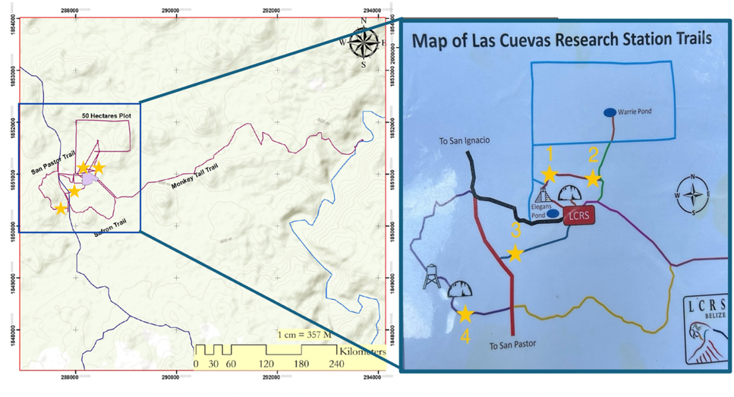
I spent two weeks in Belize – at Las Cuevas Research Station. We had two days to create and design a research project and collect data to then write up in a lab report.
I chose to study leaf cutter ants and investigate whether caste of ants (Solider or Worker ant) impacted the frequency of defence behaviours and the rate of antennation when close to or far away from the nest entrance.
I conducted 96 focal scans, which lasted 3 minutes, where ant behaviour was recorded every 5 seconds using an ethogram (see below).

There were four different ant colonies I sampled from – recorded as A. B. C. and D in the excel file. I observed 12 ants at each colony - 6 workers and 6 soldiers.

I would identify a foraging path of leaf cutter ants from a nest entrance to a tree where they were harvesting leaves from. I would divide this path into three path sections and categorise them as near nest, middle, far. Four ants were randomly selected at each path location (near, middle and far) – 2 workers and 2 soldiers. Of the two ants of each caste at each location, one was observed travelling away from the nest and one was travelling towards the nest (see simple diagram)
Near Nest
Far Nest

This was done to randomise observed ants and minimise selection bias depending on path location and activity on the foraging path. The rate of states were calculated by dividing the total number of instances where that behaviour was observed over the total time that the ant was in line of sight. I also kept a tally for antennation – when an ant interacted with another ant ( interacted with their antennae rather than just bumping into each other). I also recorded a tally of self-grooming and when an ant dropped its leaf.


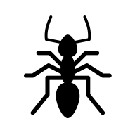
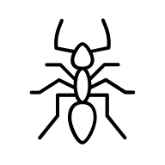












Foraging Path

SOLDIER = White/ large
WORKER = black/smaller
NEST ENTRANCE
NEAR

MIDDLE
FAR

Behaviour | Code | Description | Category
Walking | W | Ant walking without a leaf, include direction | State
Carrying | C | Ant walking and carrying a leaf, include direction
Stationary | S | Ant has voluntarily stopped, not due to obstruction
Stuck | St | Ant has stopped movement due to obstruction
Searching | Se | Ant walking perpendicularly to the main path
Patrolling | Pa | Ant walking directionally along the edge of main path
Clearing | Cl | Ant is moving debris off the main path
Picking up | Pl | Ant attempts to pick up a leaf or debris
Rearranging | R | Ant carrying an object purposefully adjusts its grip
Out of site | OOS | Ant is no longer in field of view
Antennation | A | Ant interacts and identifies another ant | Events
Self groom | SG | Ant cleans antennae and mandibles using legs
Dropped leaf | DL | Ant drops leaf, or object it was carrying

For my research project I explored whether the rate of certain behaviours was different between the different ant castes and at different locations along the foraging path. I categorised rates by combining the duration of similar states over the total time the ant was seen, not including time spent out of site. Walking states were combined as MovementRate ( blue rows), times when the ant was stationary were combined as StationaryRate ( orange rows), Searching and patrolling were combined into OffPathRate ( green rows) and others were combined as OtherProductiveRate ( pink rows).

For transparency here is my R code to combine these rates:

CleanData <- data.frame(AntData) #calling that into a data frame
CleanData[is.na(AntData)] <- 0 #cleaning the data frame and removing the NAs
CleanData

#this creates a sample time that I can then use to transform the behaviors into rates
RateData <- CleanData %>% #piping clean data into a new data frame called Rate Data
mutate(SampleTime = Total- OOS) %>% # Calculate Sample.Time based on OOS
mutate(across(Carrying.forwards:Fight, ~ .x / SampleTime*100)) # changing to a rate
#mutate(across(Antennation:Self.groom, ~ .x / 3)) #mutating across those two columns to calculate a rate per minute

RateData <- RateData %>% #this moves the sample time - oos count to after the last column, which would be in the new sample time as calculated above, so i can check and compare
relocate(Sample.Time..37.OOS.count., .after = last_col()) # moving to the last column to check
RateData

#combining movement data
CombinedRate <- RateData %>%
# Combine the four columns into a new column MovementRate and for other combined categories
mutate(MovementRate = Carrying.forwards + Carrying.backwards + Walking.forwards + Walking.backwards) %>%
mutate(StationaryRate = Stationary+Stuck) %>%
mutate(OffPathRate = Searching+Patrol) %>%
mutate(OtherProductive = Picking.up+Clearing+Rearranging+Cutting+Passengering+Allogrooming+Fight+Tug.of.war) %>%
mutate(SanityCheck = MovementRate+StationaryRate+OffPathRate+OtherProductive) %>%
#mutate(across(Antennation:Self.groom, ~ .x / 3)) %>%
dplyr::select(Sample, Colony, Caste, MovementRate, StationaryRate,OffPathRate,OtherProductive,SanityCheck,Antennation, Self.groom)

summary(CombinedRate)

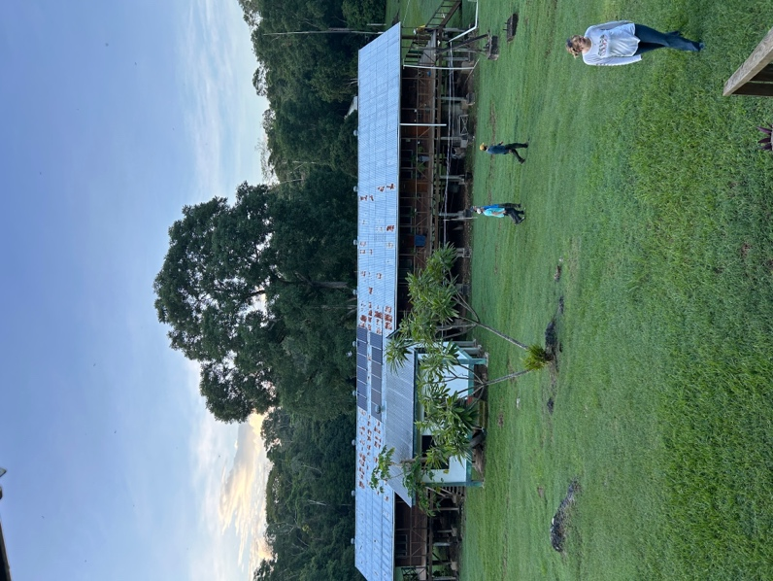
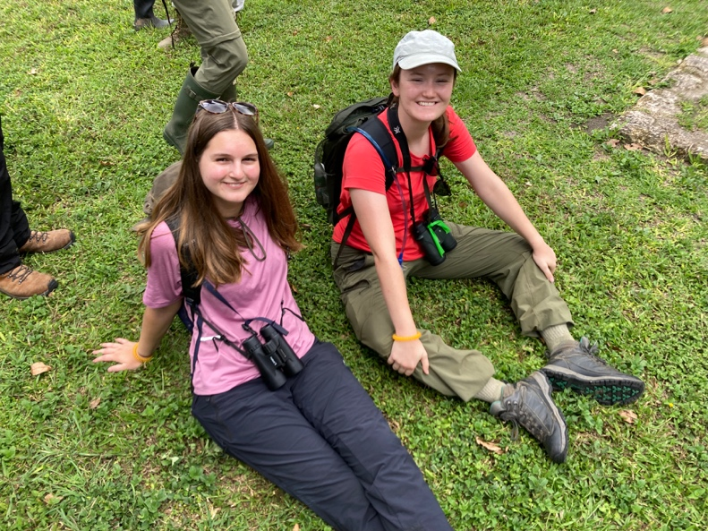
Some Fun Pictures!!!
Me and my friend who collected the data

This is the field station to the right

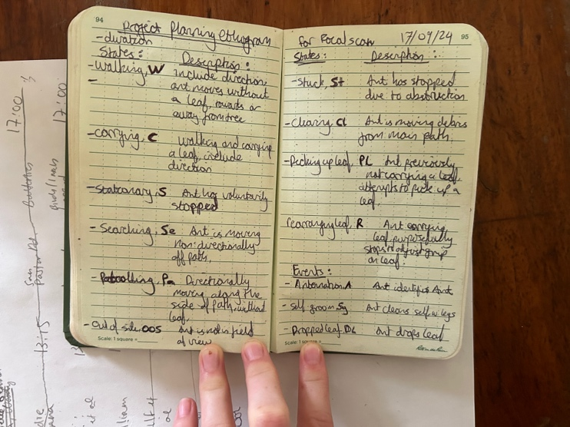

This was my ethogram in the field from my field notebook

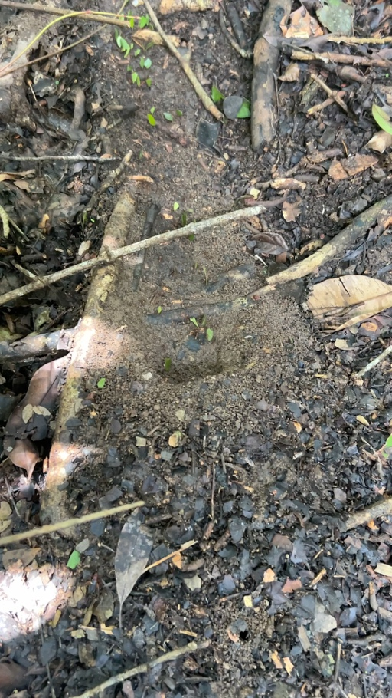
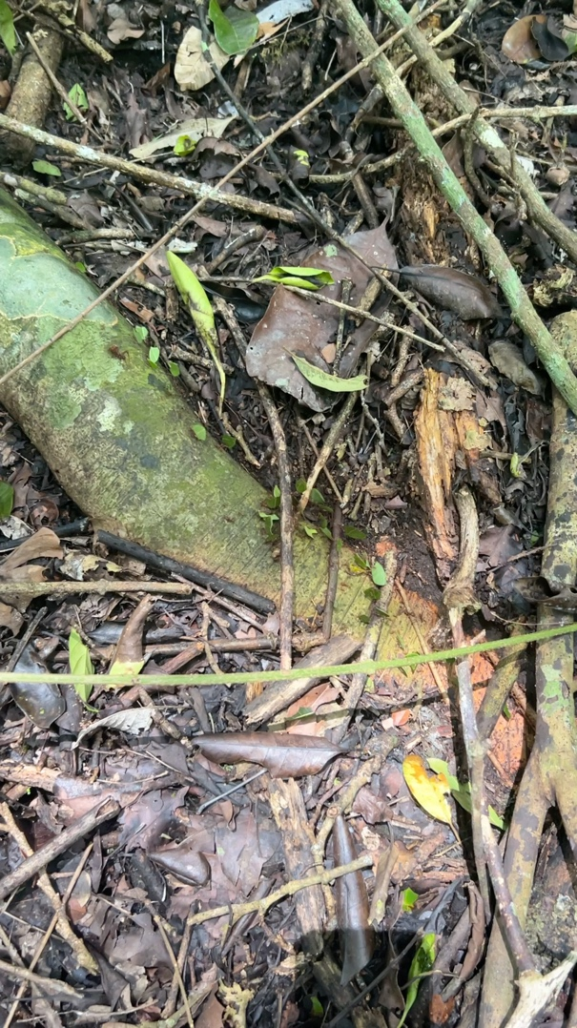
I have no idea if these videos work but it shows some ants walking along a tree root.

